**Setup Virtual Machine in VirtualBox**

In this document we will learn **how to setup a VM in virtualBox.**

**Prerequisites.**

1. Download virtualBox <https://www.virtualbox.org/wiki/Downloads> and install it

(if you getting some error)

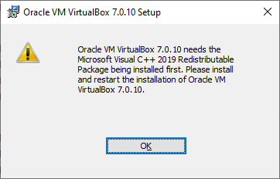

**Fig 1**

Then install Microsoft Visual C++ 2019 Redistributable from <https://aka.ms/vs/17/release/vc_redist.x86.exe> and install this first then install VBOX

1. Download CentOS iso image file from <https://ftp.riken.jp/Linux/centos/7/isos/x86_64/>

Select [CentOS-7-x86_64-DVD-2009.iso](https://ftp.riken.jp/Linux/centos/7/isos/x86_64/CentOS-7-x86_64-DVD-2009.iso)**Setup:**

Open Virtual box.

Click on New Button.

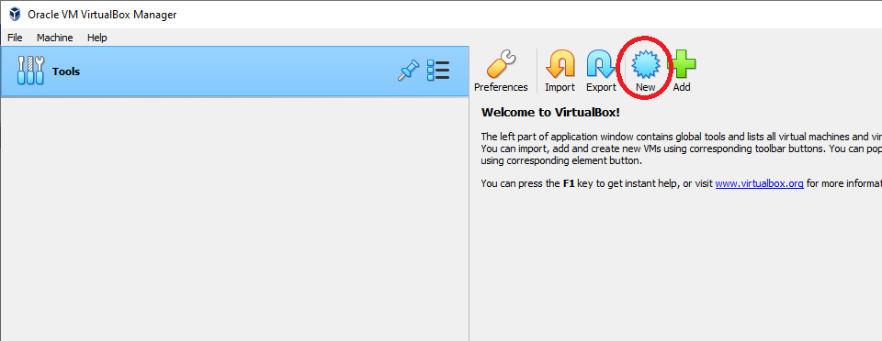

**Fig 2**

Then fill the name of the machine,

Select the location where you want to create the machine,

Select the iso image file,

& select the checkbox Skip unattended installation

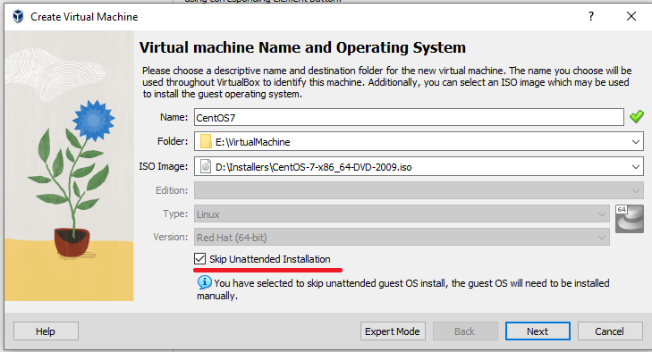

**Fig 3**

Then click on next

Then adjust the ram & processor of virtual machine according to your host machine.

For intershop **6GB** ram and 2 processors are recommanded

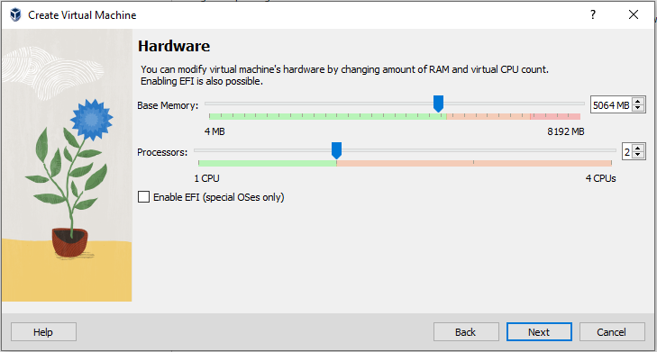

**Fig 4**

Then click on next.

In this window provide the disk size (recommended 50GB).

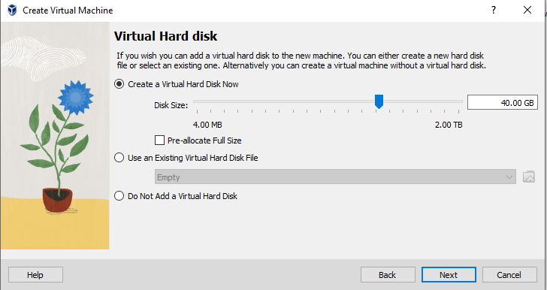

**Fig 5**

Then click on next then Finish.

Then add two more harddisks for Oracle database and Intershop files.

To do so select the vm and click on settings

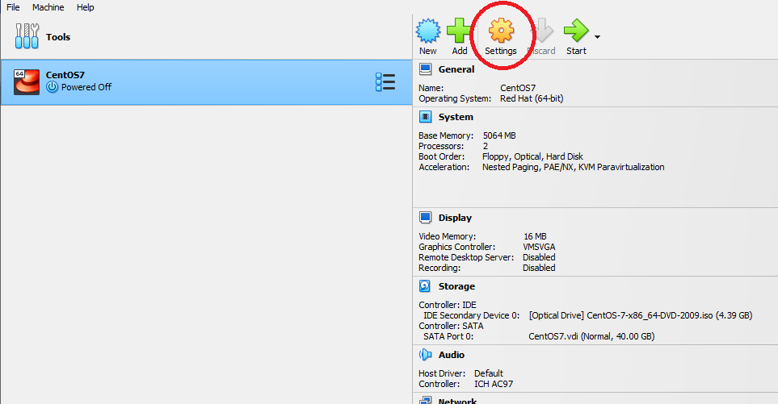

**Fig 6**

Then Select Storage

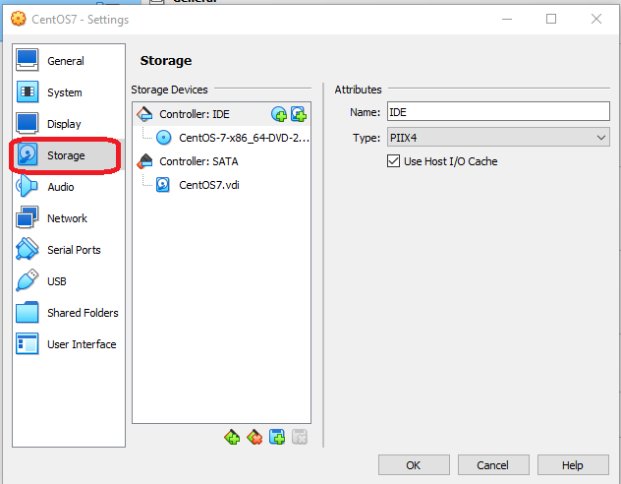

**Fig 7**

Then select new hard disk button in **Controller: SATA** section

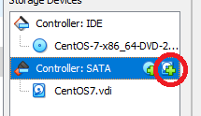

**Fig 8**

Then click on **Create**

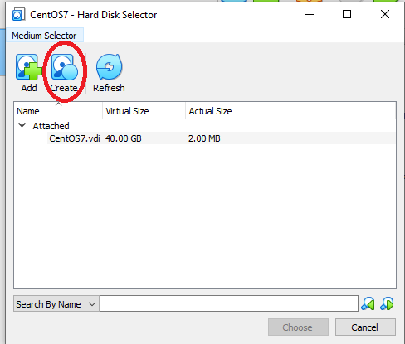

**Fig 9**

Then Select VDI and click next.

Again click next (if you want to preallocate the space select the option).

Then adjust the size and provide the name of the harddisk

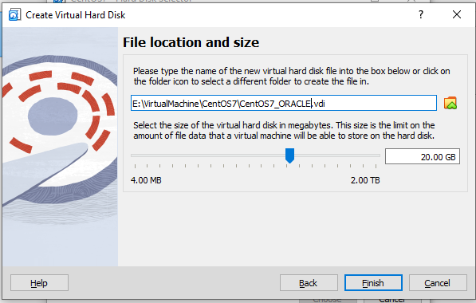

**Fig 10**

Then click on Finish.

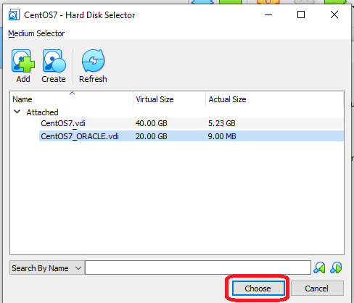

**Fig 11**

Then Select Harddisk which you have created right now. Then click on chose button.

For INTERSHOP hard disk.

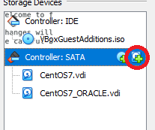

**Fig 12**

Then click on **Create**

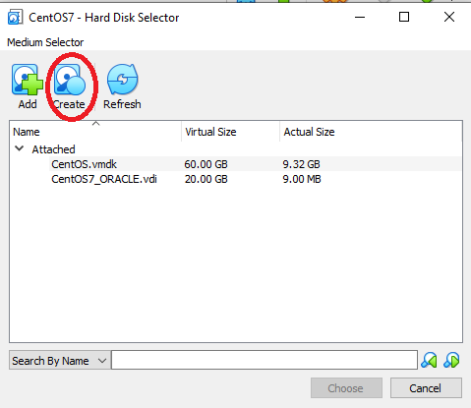

**Fig 13**

Then Select VDI and click next.

Again click next (if you want to pre-allocate the space select the option).

Then adjust the size and provide the name of the hard disk

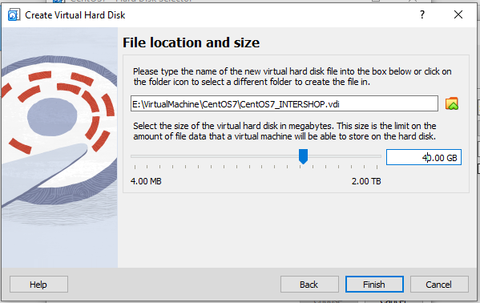

**Fig 14**

Then click on Finish.

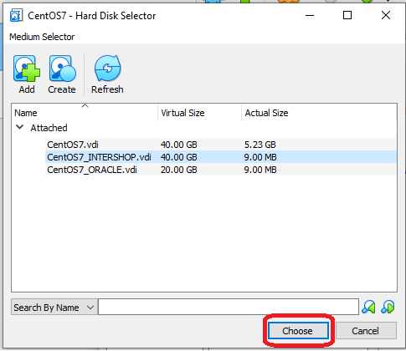

**Fig 15**

Then Select Hard disk which you have created right now. Then click on choose button.

Drives are created.

**Start the virtual machine**

When the vm is started up

Select **Install CentOS7** option. By moving up/down arrow key. Then press enter

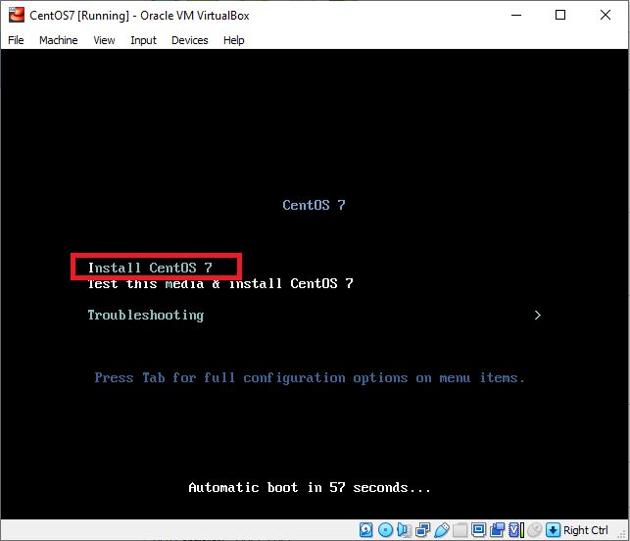

**Fig 16**

After sometime checks you will be asked for select Language.

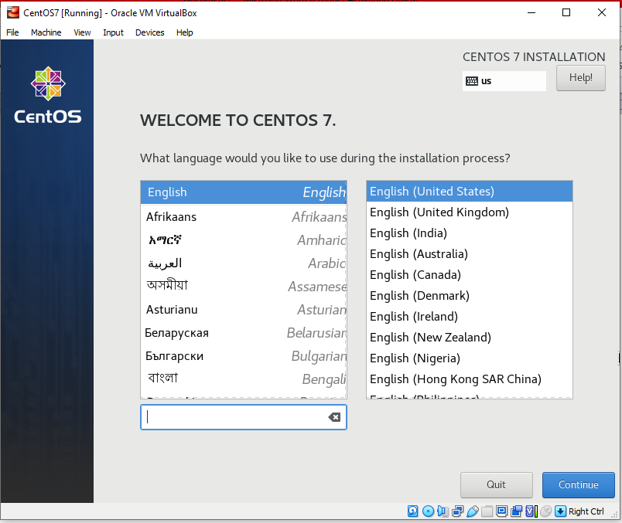

**Fig 17**

Click on continue

Then select Installation Destination section.

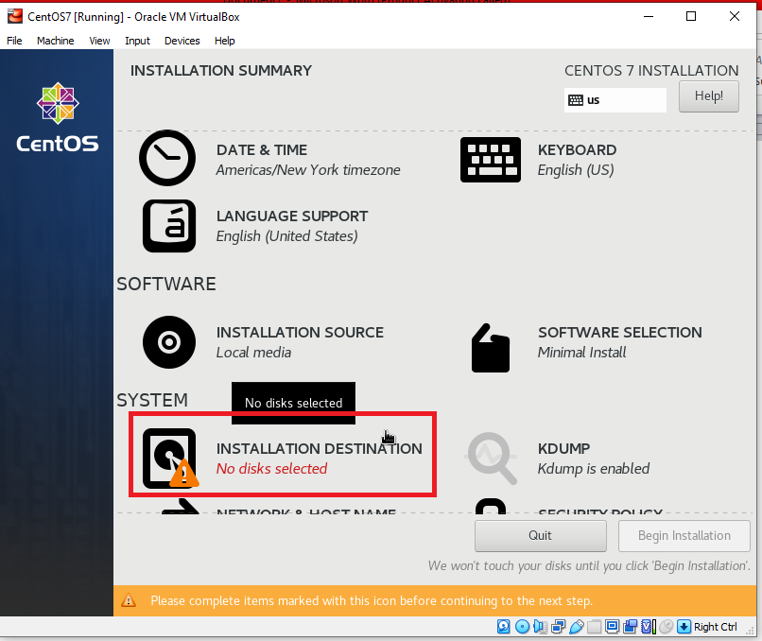

**Fig 18**

Select the right hard disk for installation (in which you want to install the Operating System)

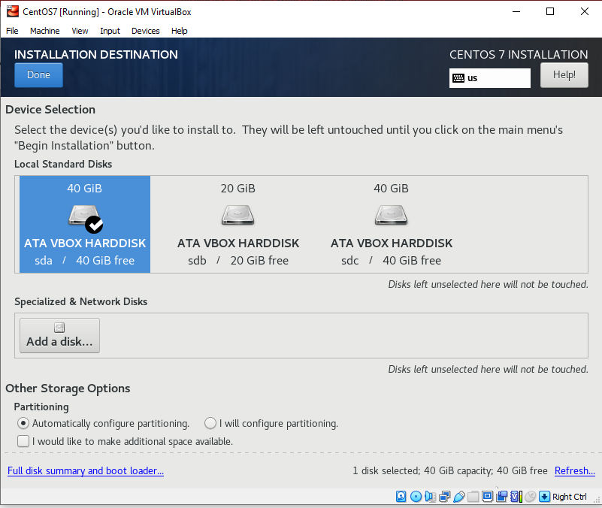

**Fig 19**

Then click Done

Then select **Software selection**

in **Base Environment** select **Development & Creative Environment**

in **Add-Ons for selected Environments** select **Development Tools**

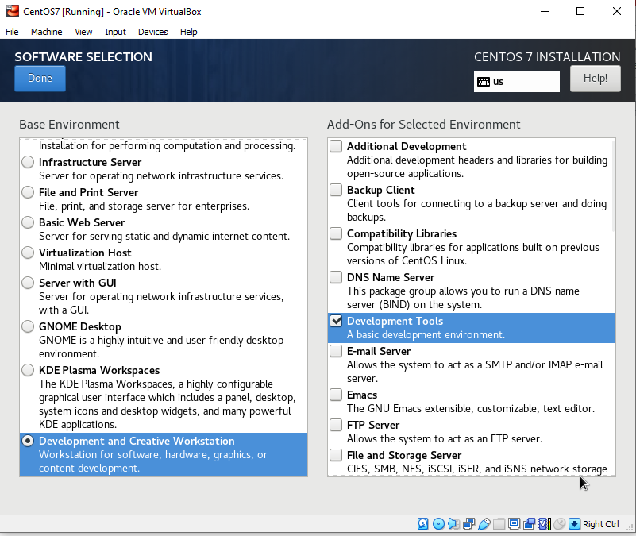

**Fig 20**

Click Done

Then begin the installation

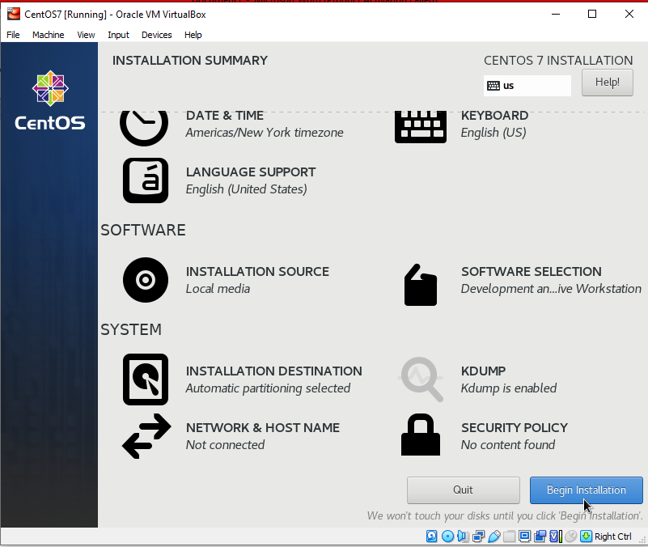

**Fig 21**

Then Set the root password from ROOT PASSWORD

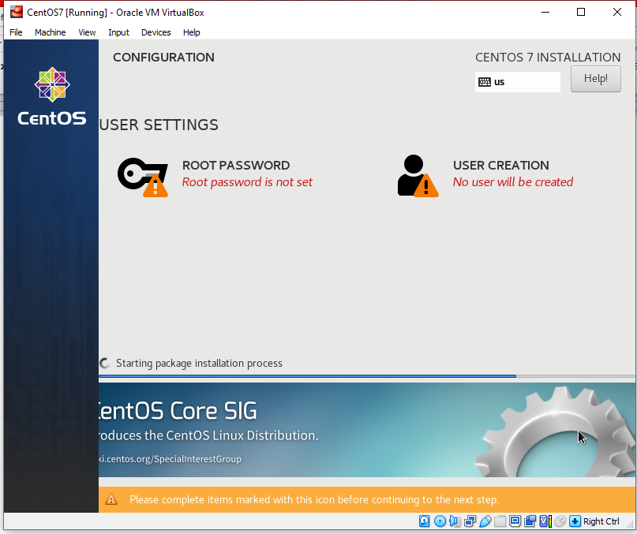

**Fig 22**

(You need to click twice on Done button if you are using a week password)

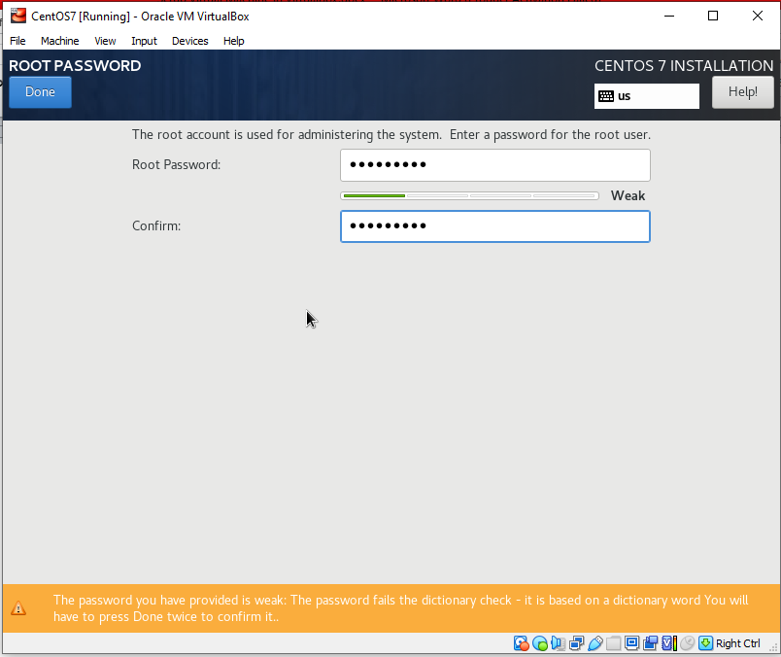

**Fig 23**

And create a user from USER CREATION

(You need to click twice on Done button if you are using a week password)

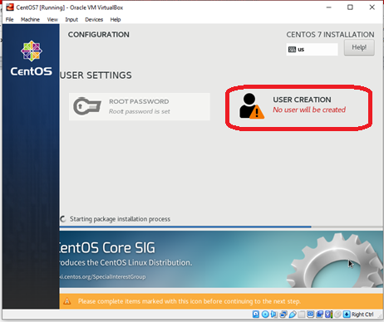

**Fig 24**

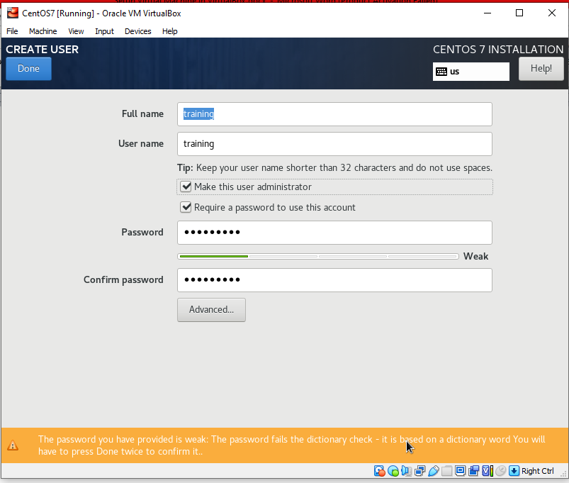

**Fig 25**

Here provide the name of the user and password.

Select the **Make the user administrator** if you want to make the user administrator.

Wait till installation is finished.

Then Click on Reboot.

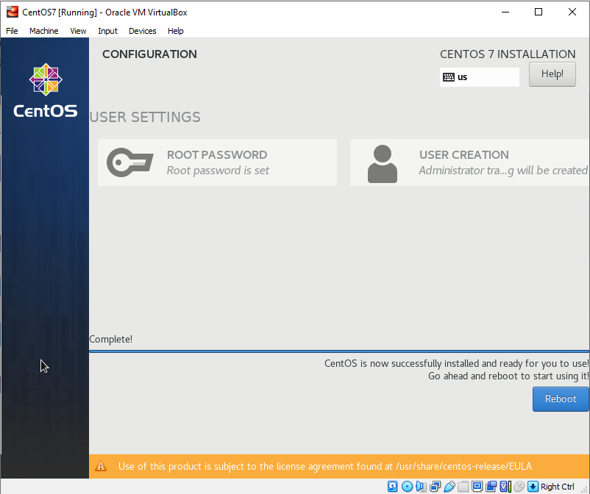

**Fig 26**

Accept the License Information.

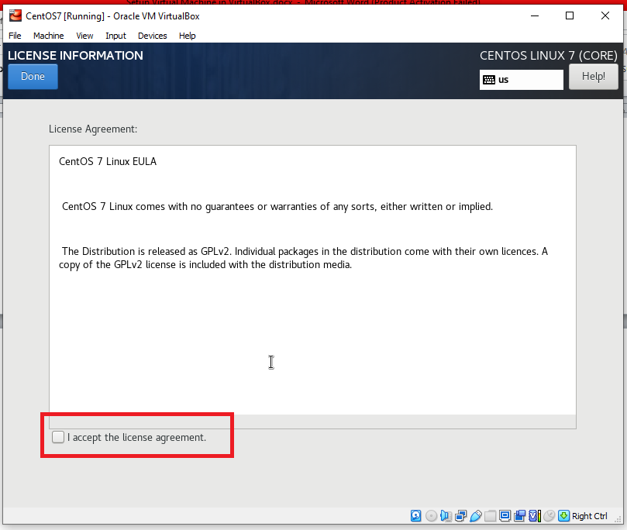

**Fig 27**

Click on **Finish Configuration**

**Install Guest Addition CD image**

Power up the virtual machine

From device menu select

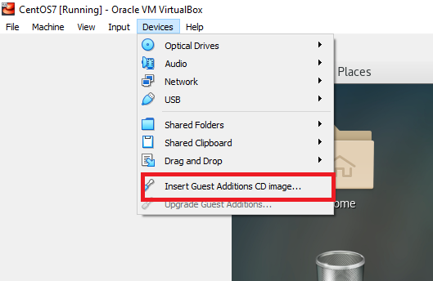

**Fig 28**

Then on virtual machine click on Run

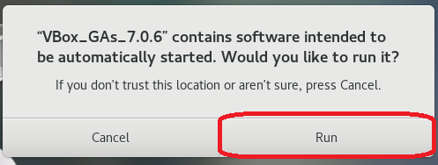

**Fig 29**

It will ask for password when you enter password it will start installing

After installation it will say

**Press enter to close the window.**

Press enter.

Reboot the virtual machine

**Make 2 more drives available which we added to our machines**

Login as root

* Run

fdisk -l

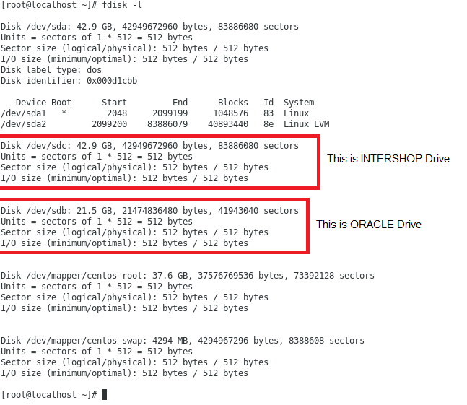

**Fig 30**

* Then run

fdisk /dev/sdb

(This hard disk is for ORACLE database)

Then type “m”

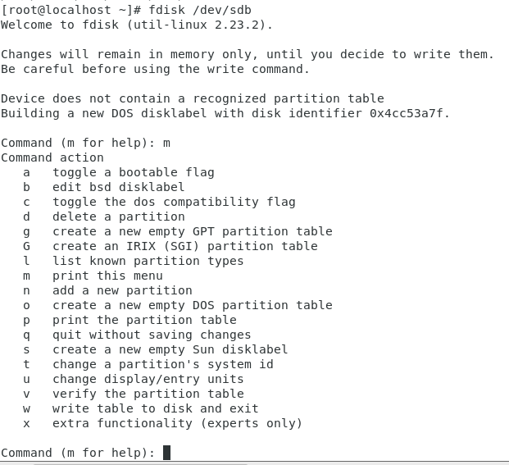

**Fig 31**

Now we will create the drive of it.

Type “n”

Then for default values press enter.

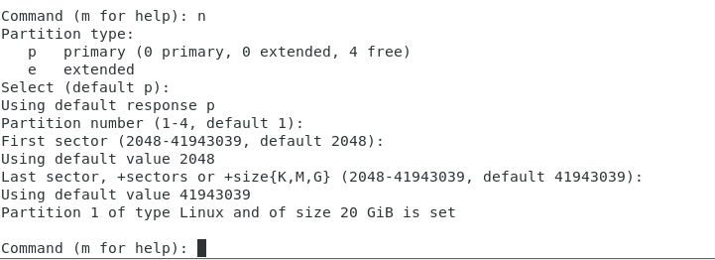

**Fig 32**

Then enter w to write the drive.

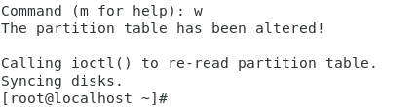

**Fig 33**

* For INTERSHOP drive.

fdisk /dev/sdb

(This hard disk is for INTERSHOP installation files)

Then type “m”

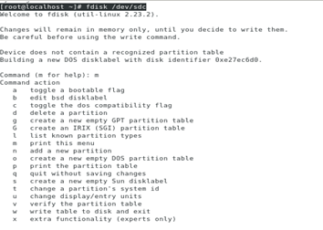

**Fig 34**

Now we will create the drive of it.

Type “n”

Then for default values press enter.

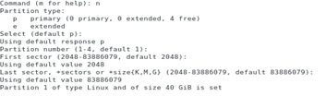

**Fig 35**

Then enter w to write the drive.



**Fig 36**

Now the Drives are created.

Now we will create the file system of this drives.

To do so run.

# mkfs.xfs /dev/sdb1 (for ORACLE Drive)

# mkfs.xfs /dev/sdc1 (for INTERSHOP Drive)

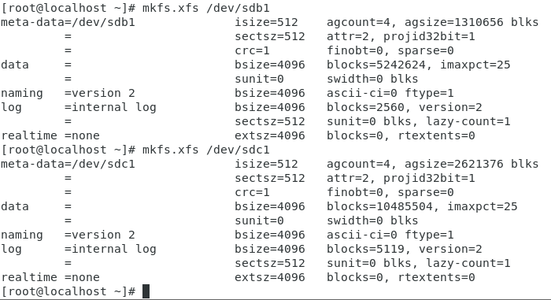

**Fig 37**

Now we have to create mount points and mount the drive to the mount points

To do so.(for oracle)

Create a directory in /

Login as root

# cd /

# mkdir /u01

# chmod 777 /u01

We are using “u01” name of the directory. Because oracle installation uses /u01 as default directory. Basically oracle databases stores in /u01 directory.

To permanently mount **ORACLE** drive in /u01

Login as root

su root

edit fstab file

vi /etc/fstab

Insert this line

/dev/sdb1 /u01 xfs defaults,x-gvfs-show,x-gvfs-name=ORACLE 0 0

Then restart

Do this for INTERSHOP drive

Create a directory in /

Login as root

# su root

# cd /

# mkdir /INTERSHOP

# chmod 777 /INTERSHOP

To permanently mount **INTERSHOP** drive in /INTERSHOP

Insert this line

/dev/sdc1 /INTERSHOP xfs defaults,x-gvfs-show,x-gvfs-name=INTERSHOP 0 0

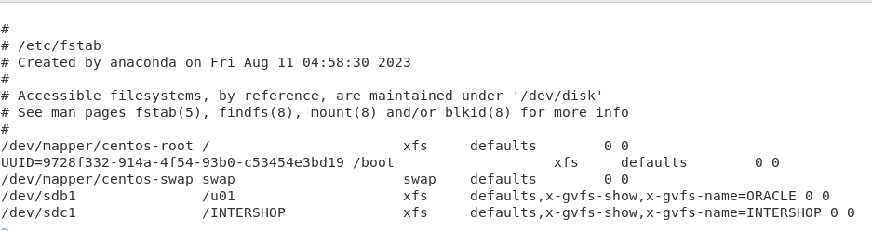

**Fig 38**

Then restart

Now you can see 2 new drives

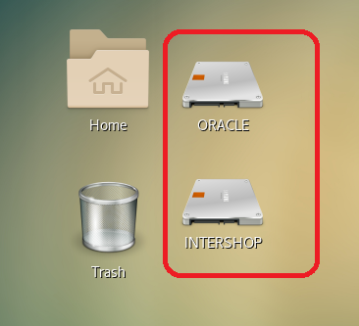

**Fig 39**